WLAN CONCEPTS

13.0.1

Why should I take this module?

Welcome to WLAN Configuration!

Some of us remember getting on the internet using dial up. Dial up involved using your landline phone. Your landline phone was unavailable to make or receive calls while you were on the internet. Your dial up connection to the internet was very slow. It basically meant that, for most people, your computer was always in one place in your home or school.

Then we were able to connect to the internet without using our landlines. But our computers were still hardwired to the devices that connected them to the internet. Today we can connect to the internet using wireless devices that lets us take our phones, laptops, and tablets almost anywhere. It’s nice to have this freedom of movement, but it requires special end and intermediary devices and a good understanding of wireless protocols. Want to know more? Then this is the module for you!

13.0.2

What will I learn to do in this module?

**Module Title**: WLAN Configuration

**Module Objective**: Implement a WLAN using a wireless router and WLC.

| Table caption | |
| --- | --- |
| **Topic Title** | **Topic Objective** |
| Remote Site WLAN Configuration | Configure a WLAN to support a remote site. |
| Configure a Basic WLAN on the WLC | Configure a WLC WLAN to use the management interface and WPA2 PSK authentication. |
| Configure a WPA2 Enterprise WLAN on the WLC | Configure a WLC WLAN to use a VLAN interface, a DHCP server, and WPA2 Enterprise authentication. |
| Troubleshoot WLAN Issues | Troubleshoot common wireless configuration issues. |

**REMOTE WLAN CONFIGURATIONS**

13.1.2

## The Wireless Router

Remote workers, small branch offices, and home networks often use a small office and home router. These routers are sometimes called an integrated router because they typically include a switch for wired clients, a port for an internet connection (sometimes labeled “WAN”), and wireless components for wireless client access, as shown for the Cisco Meraki MX64W in the figure. For the rest of this module, small office and home routers are referred to as wireless routers.

The figure shows the back of a small office or home router. The router has two antennas, one on each side. On the left, there is a reset button. Next to the reset button there are four ports for LAN devices to connect. Then theres a port for the WAN connection and finally the the power button and the port for the power cord.

### **Cisco Meraki MX64W**

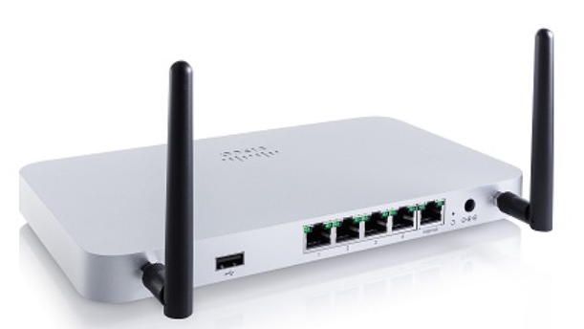

The next figure shows a topology depicting the physical connection of a wired laptop to the wireless router, which is then connected to a cable or DSL modem for internet connectivity.

The figure depicts the physical connection of a wired laptop to the wireless router, which is then connected to a cable or DSL modem for internet connectivity. It shows a person sitting at a computer desk. Connected to the back of the desktop computer is a link going to a wireless router and from the wireless router theres a link going to the broadband modem. The broadband modem has a serial connection to the Internet depicted by a cloud.

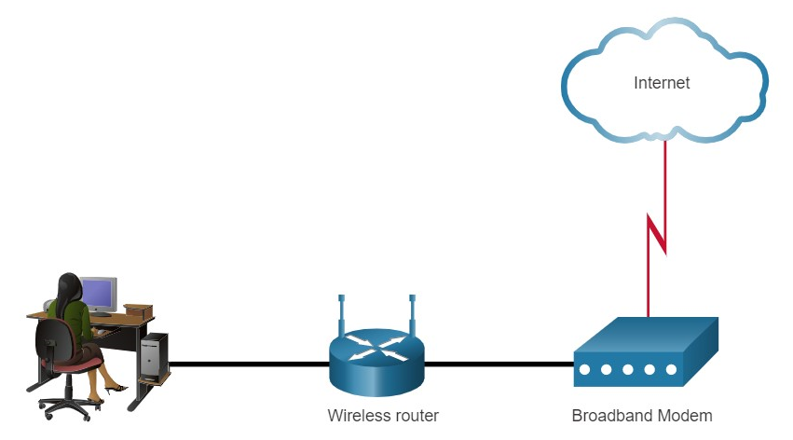

These wireless routers typically provide WLAN security, DHCP services, integrated Name Address Translation (NAT), quality of service (QoS), as well as a variety of other features. The feature set will vary based on the router model.

**Note**: Cable or DSL modem configuration is usually done by the service provider’s representative either on-site or remotely through a walkthrough with you on the phone. If you buy the modem, it will come with documentation for how to connect it to your service provider which will most likely include contacting your service provider for more information.

13.1.3

Log in to the Wireless Router

Most wireless routers are ready for service out of the box. They are preconfigured to be connected to the network and provide services. For example, the wireless router uses DHCP to automatically provide addressing information to connected devices. However, wireless router default IP addresses, usernames, and passwords can easily be found on the internet. Just enter the search phrase “default wireless router IP address” or “default wireless router passwords” to see a listing of many websites that provide this information. For example, username and password for the wireless router in the figure is “admin”. Therefore, your first priority should be to change these defaults for security reasons.

To gain access to the wireless router’s configuration GUI, open a web browser. In the address field, enter the default IP address for your wireless router. The default IP address can be found in the documentation that came with the wireless router or you can search the internet. The figure shows the IPv4 address 192.168.0.1, which is a common default for many manufacturers. A security window prompts for authorization to access the router GUI. The word admin is commonly used as the default username and password. Again, check your wireless router’s documentation or search the internet.

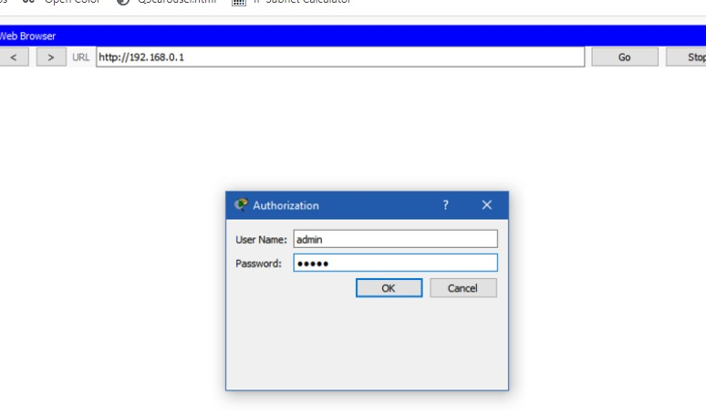

13.1.4

## Basic Network Setup

Basic network setup includes the following steps:

1. Log in to the router from a web browser.
2. Change the default administrative password.
3. Log in with the new administrative password.
4. Change the default DHCP IPv4 addresses.
5. Renew the IP address.
6. Log in to the router with the new IP address.

**1. Log in to the router from a web browser.**

After logging in, a GUI opens. The GUI will have tabs or menus to help you navigate to various router configuration tasks. It is often necessary to save the settings changed in one window before proceeding to another window. At this point, it is a best practice to make changes to the default settings.

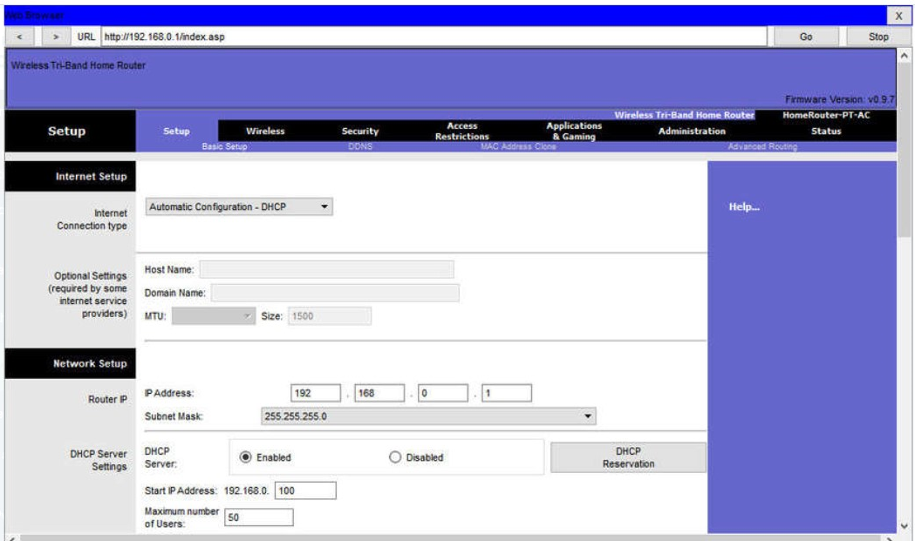

**2. Change the default administrative password.**

To change the default login password, find the administration portion of the router’s GUI. In this example, the Administration tab was selected. This is where the router password can be changed. On some devices, such as the one in the example, you can only change the password. The username remains admin or whatever the default username is for the router you are configuring.

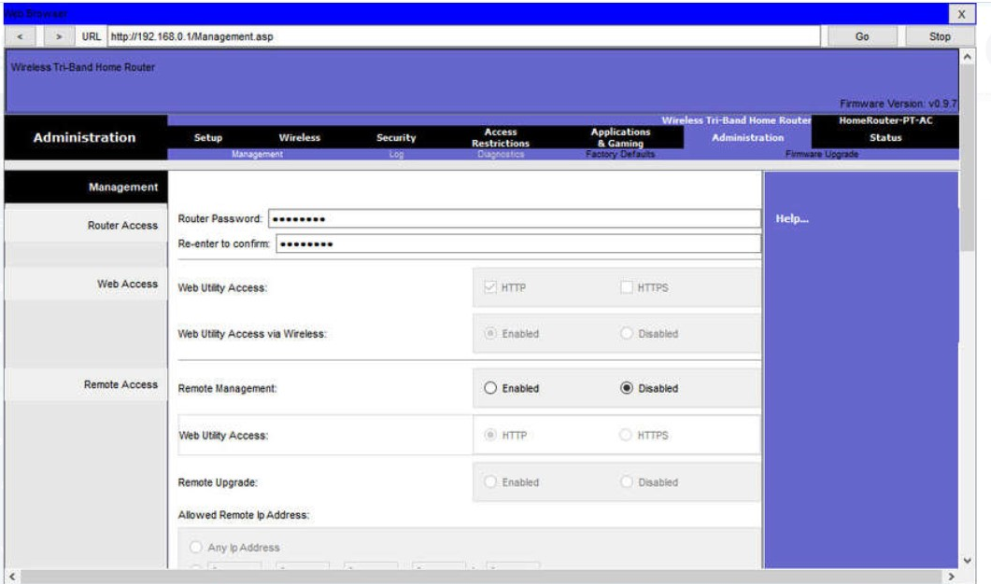

**3. Log in with the new administrative password.**

After you save the new password, the wireless router will request authorization again. Enter the username and new password, as shown in the example.

Click the next step.

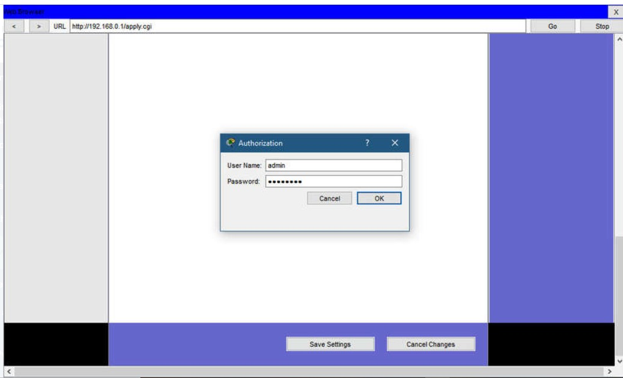

**4. Change the default DHCP IPv4 addresses.**

Change the default router IPv4 address. It is a best practice to use private IPv4 addressing inside your network. The IPv4 address 10.10.10.1 is used in the example but it could be any private IPv4 address you choose.

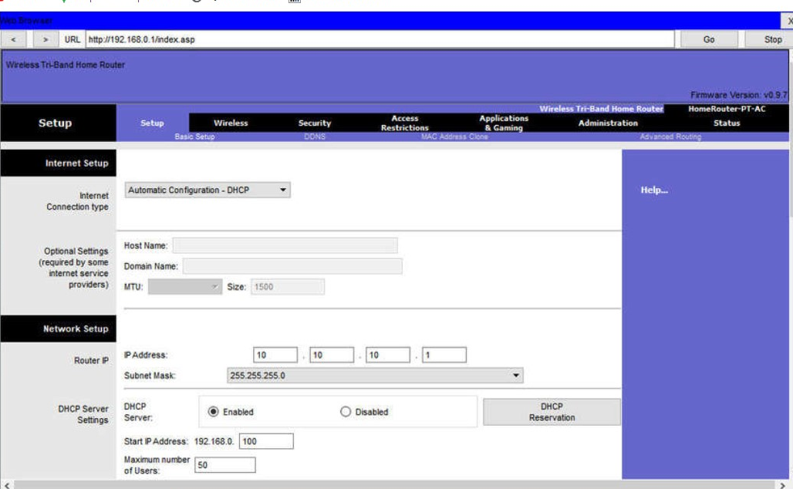

**5. Renew the IP address.**

When you click save, you will temporarily lose access to the wireless router. Open a command window and renew your IP address with the ipconfig /renew command, as shown in the example.

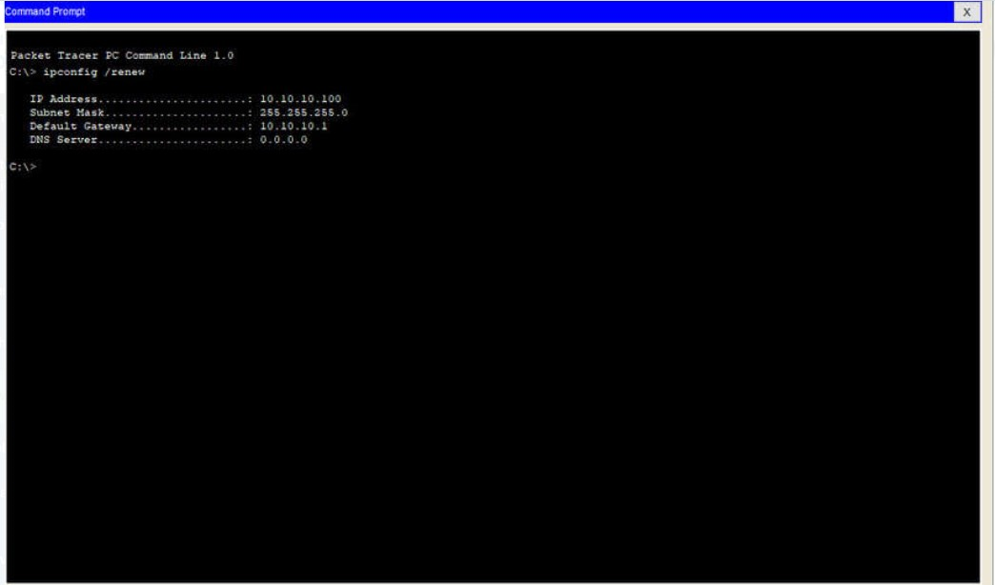

**6. Log in to the router with the new IP address.**

Enter the router’s new IP address to regain access to the router configuration GUI, as shown in the example. You are now ready to continue configuring the router for wireless access.

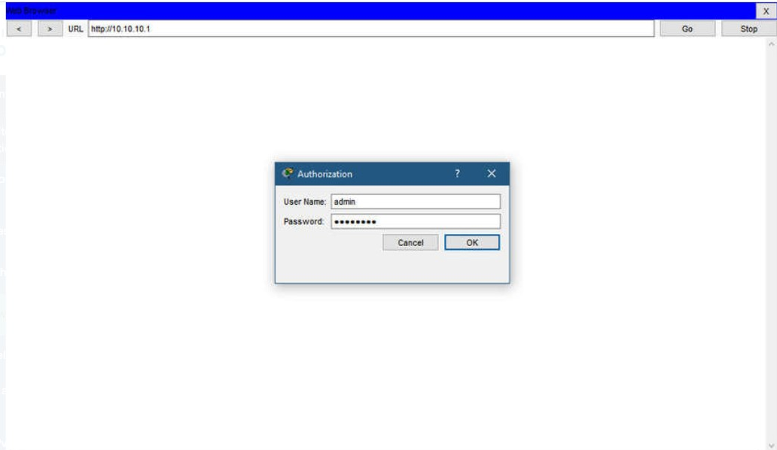

13.1.5

## Basic Wireless Setup

Basic wireless setup includes the following steps:

1. View the WLAN defaults.
2. Change the network mode.
3. Configure the SSID.
4. Configure the channel.
5. Configure the security mode.
6. Configure the passphrase.

**1. View the WLAN defaults.**

Out of the box, a wireless router provides wireless access to devices using a default wireless network name and password. The network name is called the Service Set Identified (SSID). Locate the basic wireless settings for your router to change these defaults, as shown in the example.

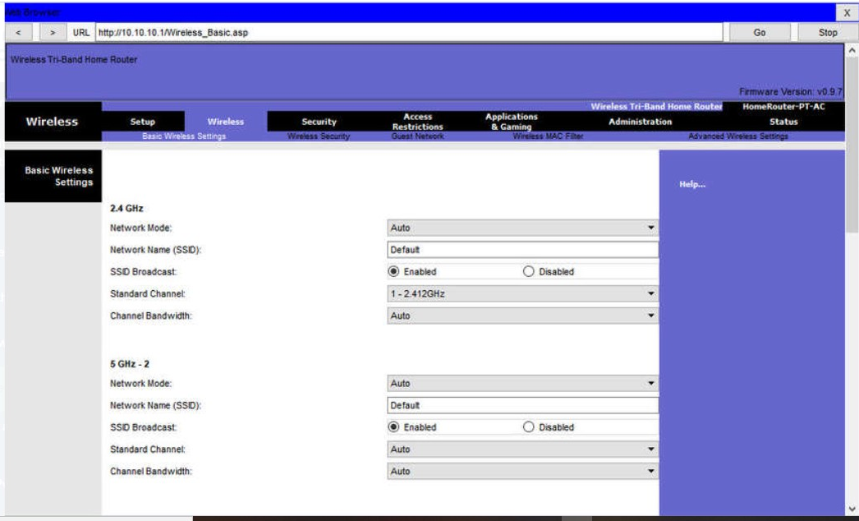

**2. Change the network mode.**

Some wireless routers allow you to select which 802.11 standard to implement. The example shows that “Legacy” has been selected. This means wireless devices connecting to the wireless router can have a variety of wireless NICs installed. Today’s wireless routers configured for legacy or mixed mode most likely support 802.11a, 802.11n, and 802.11ac NICs.

Click the next step.

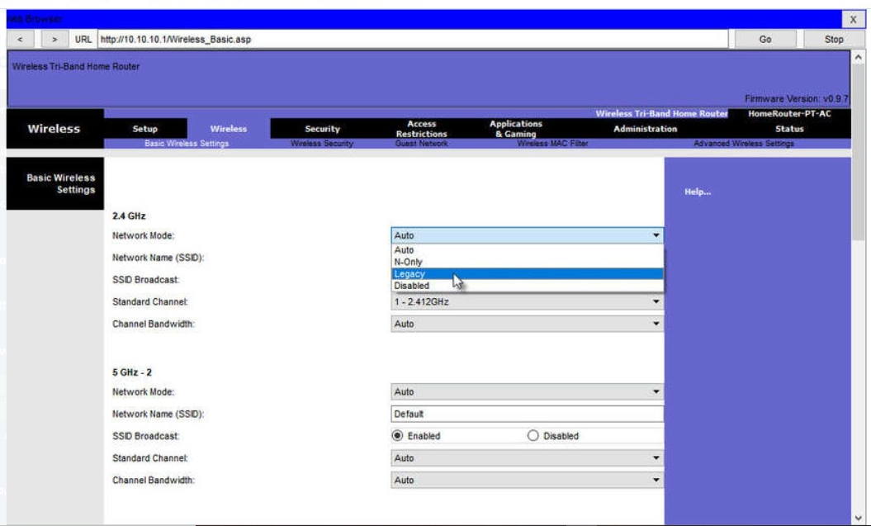

**3. Configure the SSID.**

Assign an SSID to the WLANs. OfficeNet is used in the example for all three WLANs (the third WLAN is not shown). The wireless router announces its presence by sending broadcasts advertising its SSID. This allows wireless hosts to automatically discover the name of the wireless network. If the SSID broadcast is disabled, you must manually enter the SSID on each wireless device that connects to the WLAN.

Click the next step.

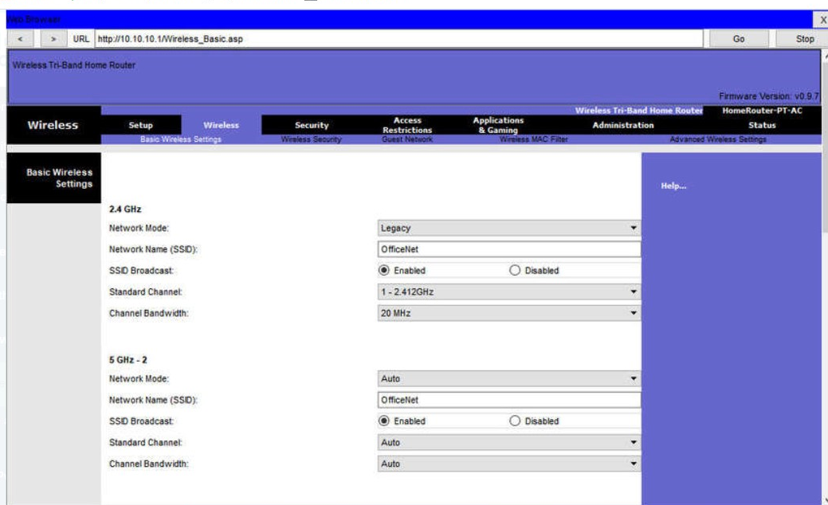

**4. Configure the channel.**

Devices configured with the same channel within the 2.4GHz band may overlap and cause distortion, slowing down the wireless performance and potentially break network connections. The solution to avoid interference is to configure non-overlapping channels on the wireless routers and access points that are near to each other. Specifically, channels 1, 6, and 11 are non-overlapping. In the example, the wireless router is configured to use channel 6.

Click the next step.

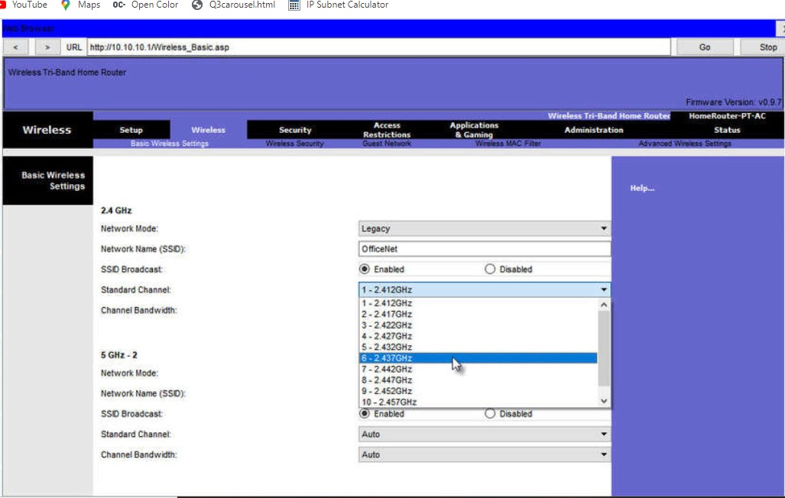

**5. Configure the security mode.**

Out of the box, a wireless router may have no WLAN security configured. In the example, the personal version of Wi-Fi Protected Access version 2 (WPA2 Personal) is selected for all three WLANs. WPA2 with Advanced Encryption Standard (AES) encryption is currently the strongest security mode.

Click the next step.

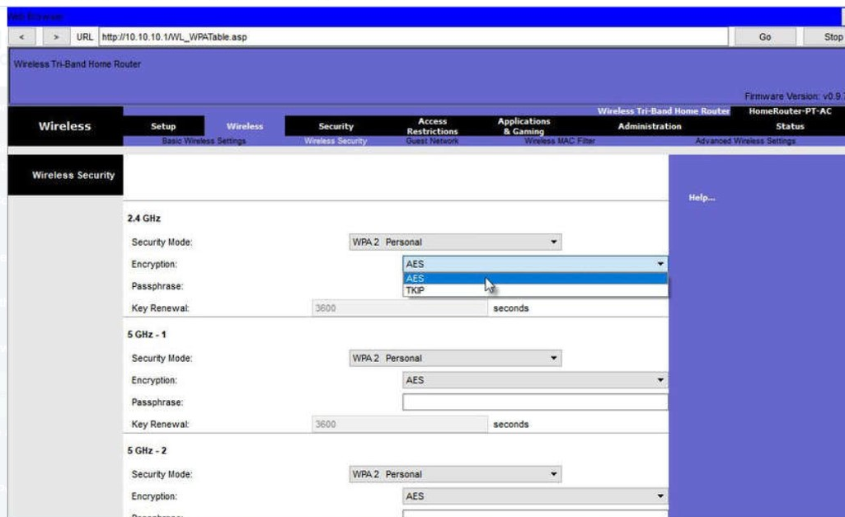

**6. Configure the passphrase.**

WPA2 personal uses a passphrase to authenticate wireless clients. WPA2 personal is easier to use in a small office or home environment because it does not require an authentication server. Larger organizations implement WPA2 enterprise and require wireless clients to authenticate with a username and password.

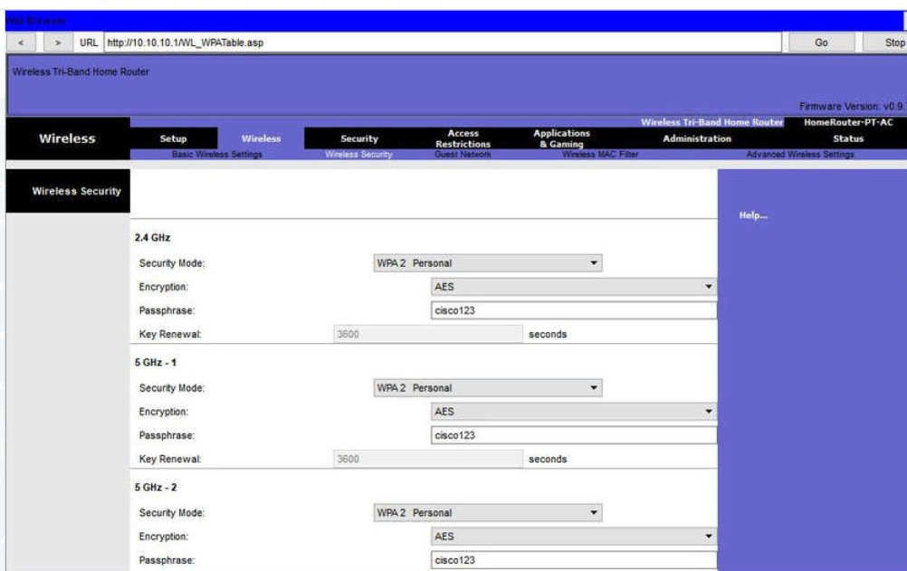

13.1.6

Configure a Wireless Mesh Network

In a small office or home network, one wireless router may suffice to provide wireless access to all the clients. However, if you want to extend the range beyond approximately 45 meters indoors and 90 meters outdoors, you can add wireless access points. As shown in the wireless mesh network in the figure, two access points are configured with the same WLAN settings from our previous example. Notice that the channels selected are 1 and 11 so that the access points do not interfere with channel 6 configured previously on the wireless router.

The figure depicts two wireless access points in a small office or home network. The wireless access points connect wirelessly to a router. The router is connected to a broadband modem. The broadband modem is connected to a cloud depicting the Internet. There are arrows pointing from the wireless access points showing the configuration settings. One wireless access point is on channel 1 on 2.4GHz and the other is on channel 11 on 2.4GHz.

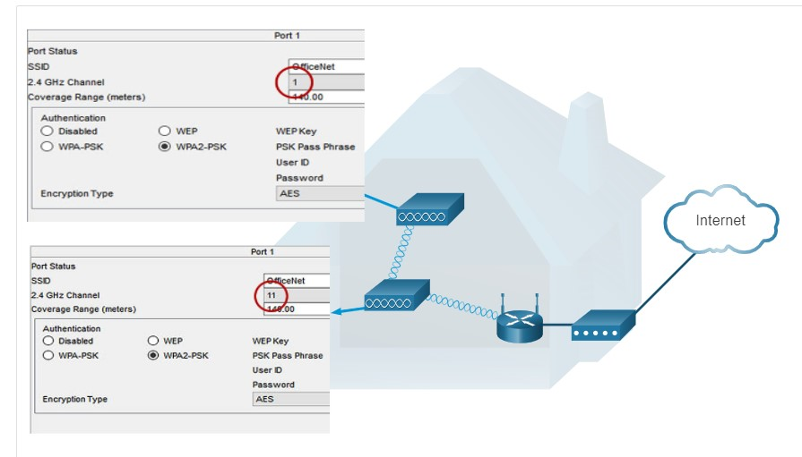

Extending a WLAN in a small office or home has become increasingly easier. Manufacturers have made creating a wireless mesh network (WMN) simple through smartphone apps. You buy the system, disperse the access points, plug them in, download the app, and configure your WMN in a few steps. Search the internet for “best wi-fi mesh network system” to find reviews of current offerings.

13.1.7

NAT for IPv4

On a wireless router, if you look for a page like the Status page shown in the figure, you will find the IPv4 addressing information that the router uses to send data to the internet. Notice that the IPv4 address is 209.165.201.11 is a different network than the 10.10.10.1 address assigned to the router’s LAN interface. All the devices on the router’s LAN will get assigned addresses with the 10.10.10 prefix.

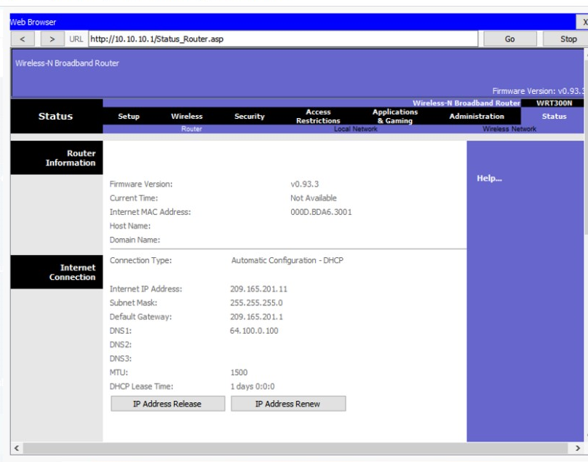

The 209.165.201.11 IPv4 address is publicly routable on the internet. Any address with the 10 in the first octet is a private IPv4 address and cannot be routed on the internet. Therefore, the router will use a process called Network Address Translation (NAT) to convert private IPv4 addresses to internet-routable IPv4 addresses. With NAT, a private (local) source IPv4 address is translated to a public (global) address. The process is reversed for incoming packets. The router is able to translate many internal IPv4 addresses into public addresses, by using NAT.

Some ISPs use private addressing to connect to customer devices. However, eventually, your traffic will leave the provider’s network and be routed on the internet. To see the IP addresses for your devices, search the internet for “what is my IP address.” Do this for other devices on the same network and you will see that they all share the same public IPv4 address. NAT makes this possible by tracking the source port numbers for every session established by a device. If your ISP has IPv6 enabled, you will see a unique IPv6 address for each device.

13.1.8

Quality of Service

Many wireless routers have an option for configuring Quality of Service (QoS). By configuring QoS, you can guarantee that certain traffic types, such as voice and video, are prioritized over traffic that is not as time-sensitive, such as email and web browsing. On some wireless routers, traffic can also be prioritized on specific ports.

The figure is a simplified mockup of a QoS interface based on a Netgear GUI. You will usually find the QoS settings in the advanced menus. If you have a wireless router available, investigate the QoS settings. Sometimes, these might be listed under “bandwidth control” or something similar. Consult the wireless router’s documentation or search the internet for “qos settings” for your router’s make and model.

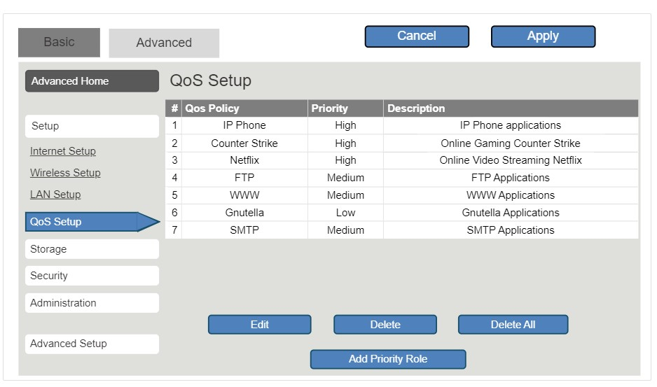

13.1.9

Port Forwarding

Wireless routers typically block TCP and UDP ports to prevent unauthorized access in and out of a LAN. However, there are situations when specific ports must be opened so that certain programs and applications can communicate with devices on different networks. Port forwarding is a rule-based method of directing traffic between devices on separate networks.

When traffic reaches the router, the router determines if the traffic should be forwarded to a certain device based on the port number found with the traffic. For example, a router might be configured to forward port 80, which is associated with HTTP. When the router receives a packet with the destination port of 80, the router forwards the traffic to the server inside the network that serves web pages. In the figure, port forwarding is enabled for port 80 and is associated with the web server at IPv4 address 10.10.10.50.

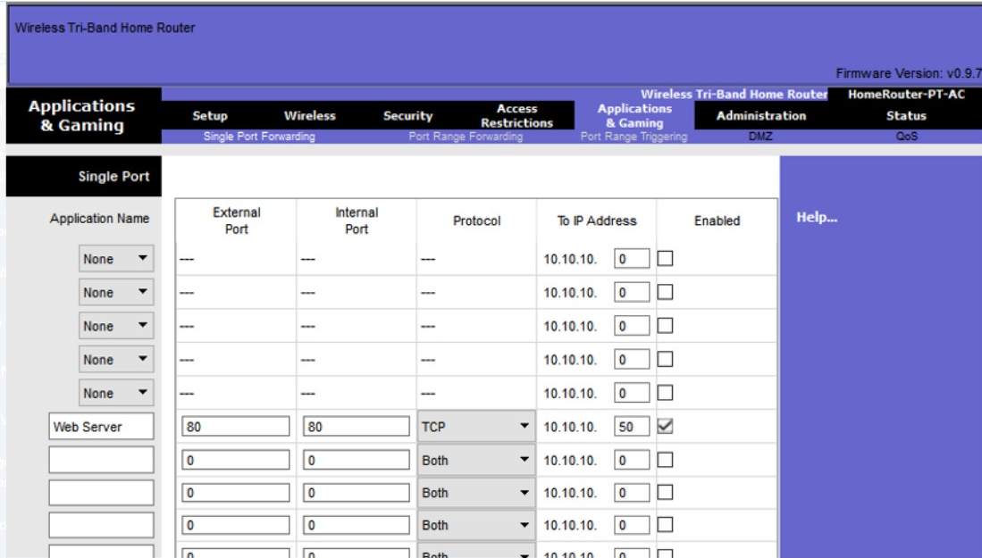

Port triggering allows the router to temporarily forward data through inbound ports to a specific device. You can use port triggering to forward data to a computer only when a designated port range is used to make an outbound request. For example, a video game might use ports 27000 to 27100 for connecting with other players. These are the trigger ports. A chat client might use port 56 for connecting the same players so that they can interact with each other. In this instance, if there is gaming traffic on an outbound port within the triggered port range, inbound chat traffic on port 56 is forwarded to the computer that is being used to play the video game and chat with friends. When the game is over and the triggered ports are no longer in use, port 56 is no longer allowed to send traffic of any type to this computer.

13.1.10

Packet Tracer - Configure a Wireless Network(pending 13.1.10)

In this activity, you will configure a wireless router and an access point to accept wireless clients and route IP packets.

13.1.11

Lab - Configure a Wireless Network(pending)

In this lab, you will configure basic settings on a wireless router and connect a PC to router wirelessly

**CONFIGURE A BASIC WLAN ON THE WLC**

13.2.2

## WLC Topology

The topology and addressing scheme used for the videos and this topic are shown in the figure and the table. The access point (AP) is a controller-based AP as opposed to an autonomous AP. Recall that controller-based APs require no initial configuration and are often called lightweight APs (LAPs). LAPs use the Lightweight Access Point Protocol (LWAPP) to communicate with a WLAN controller (WLC). Controller-based APs are useful in situations where many APs are required in the network. As more APs are added, each AP is automatically configured and managed by the WLC.

The figure shows a wireless LAN controller (WLC) topology. PC-A is a RADIUS/SNMP Server connected to R1 on R1s F0/0 interface. PC-B is connected to S1 on S1s F0/6 port. R1 and S1 are connected together on R1s F0/1 interface and on S1s F0/5 interface. S1 is connected to a WLC on its F0/18 port. On S1s F0/1 port its connected to an access point, AP1. A laptop is wirelessly connected to AP1.

### **Topology**

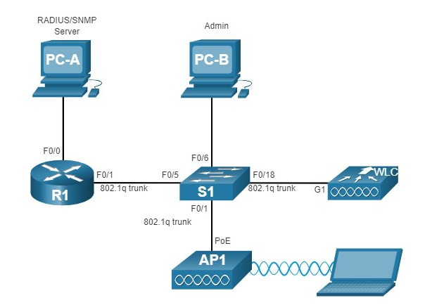

### **Addressing Table**

| DeviceInterfaceIP AddressSubnet MaskR1F0/0172.16.1.1255.255.255.0R1F0/1.1192.168.200.1255.255.255.0S1VLAN 1DHCPWLCManagement192.168.200.254255.255.255.0AP1Wired 0192.168.200.3255.255.255.0PC-ANIC172.16.1.254255.255.255.0PC-BNICDHCPWireless LaptopNICDHCP | | | |
| --- | --- | --- | --- |
| **Device** | **Interface** | **IP Address** | **Subnet Mask** |
| R1 | F0/0 | 172.16.1.1 | 255.255.255.0 |
| R1 | F0/1.1 | 192.168.200.1 | 255.255.255.0 |
| S1 | VLAN 1 | DHCP | |
| WLC | Management | 192.168.200.254 | 255.255.255.0 |
| AP1 | Wired 0 | 192.168.200.3 | 255.255.255.0 |
| PC-A | NIC | 172.16.1.254 | 255.255.255.0 |
| PC-B | NIC | DHCP | |
| Wireless Laptop | NIC | DHCP | |

13.2.3

Log in to the WLC

Configuring a wireless LAN controller (WLC) is not that much different from configuring a wireless router. The big difference is that a WLC controls APs and provides more services and management capabilities, many of which are beyond the scope of this module.

**Note**: The figures in this topic that show the graphical user interface (GUI) and menus are from a Cisco 3504 Wireless Controller. However, other WLC models will have similar menus and features.

The figure shows the user logging into the WLC with credentials that were configured during initial setup.

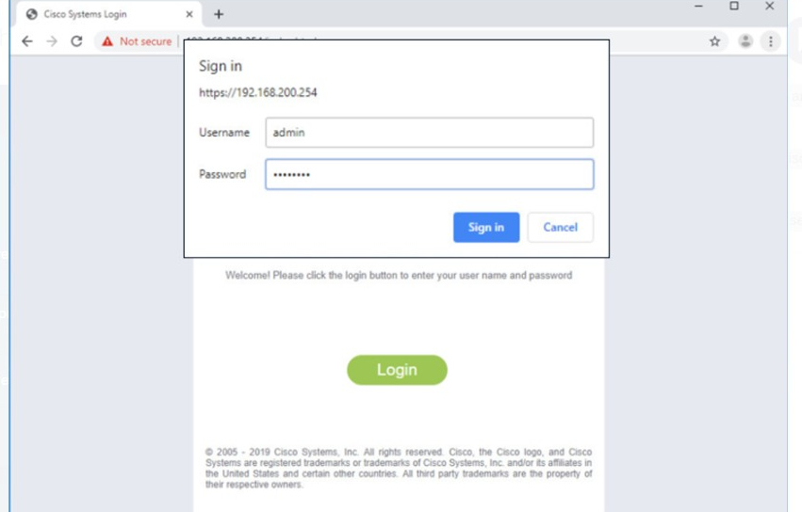

The **Network Summary** page is a dashboard that provides a quick overview of the number of configured wireless networks, associated access points (APs), and active clients. You can also see the number of rogue access points and clients, as shown in the figure.

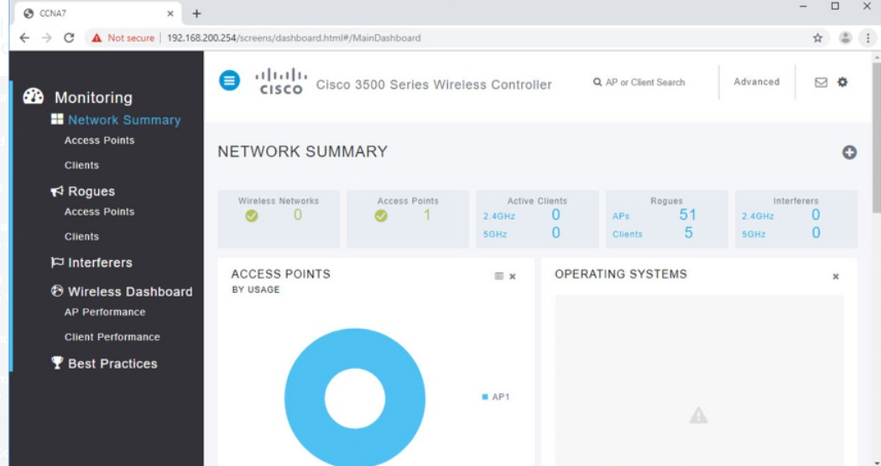

13.2.4

View AP Information

Click **Access Points** from the left menu to view an overall picture of the AP’s system information and performance, as shown in the next figure. The AP is using IP address 192.168.200.3. Because Cisco Discovery Protocol (CDP) is active on this network, the WLC knows that the AP is connected to the FastEthernet 0/1 port on the s

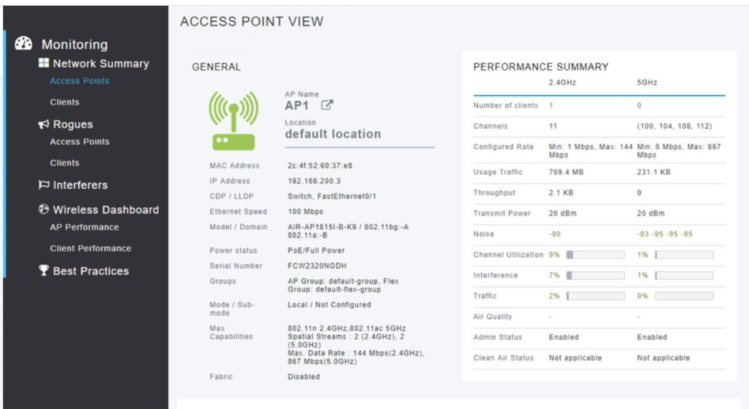

This AP in the topology is a Cisco Aironet 1815i which means you can use the command-line and a limited set of familiar IOS commands. In the example, the network administrator pinged the default gateway, pinged the WLC, and verified the wired interface.

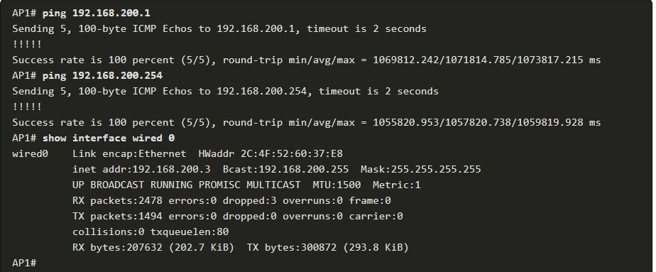

13.2.5

Advanced Settings

Most WLC will come with some basic settings and menus that users can quickly access to implement a variety of common configurations. However, as a network administrator, you will typically access the advanced settings. For the Cisco 3504 Wireless Controller, click **Advanced** in the upper right-hand corner to access the advanced **Summary** page, as shown in the figure. From here, you can access all the features of the WLC.

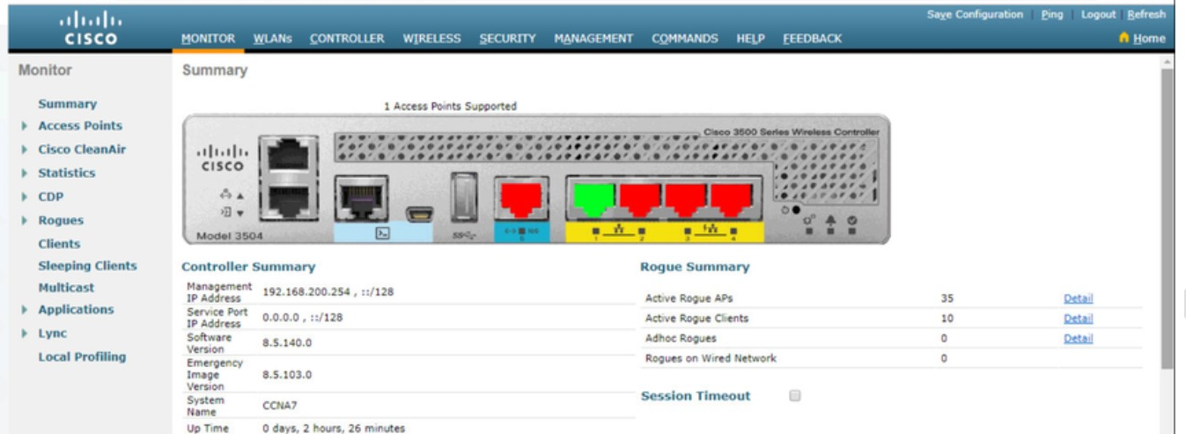

13.2.6

Configure a WLAN

Wireless LAN Controllers have ports and interfaces. Ports are the sockets for the physical connections to the wired network. They resemble switch ports. Interfaces are virtual. They are created in software and are very similar to VLAN interfaces. In fact, each interface that will carry traffic from a WLAN is configured on the WLC as a different VLAN. The Cisco 3504 WLC can support 150 access points and 4096 VLANs, however it only has five physical ports, as shown in the figure. This means that each physical port can support many APs and WLANs. The ports on the WLC are essentially trunk ports that can carry traffic from multiple VLANs to a switch for distribution to multiple APs. Each AP can support multiple WLANs.

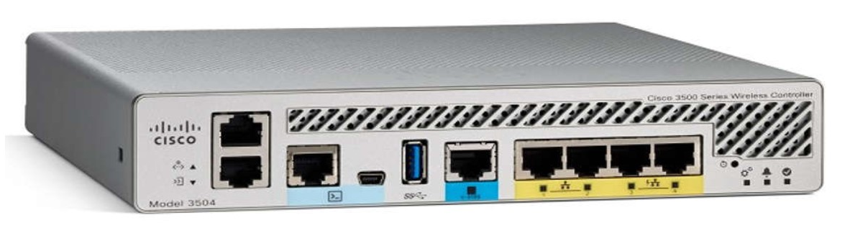

Basic WLAN configuration on the WLC includes the following steps:

1. Create the WLAN
2. Apply and Enable the WLAN
3. Select the Interface
4. Secure the WLAN
5. Verify the WLAN is Operational
6. Monitor the WLAN
7. View Wireless Client Information

**1. Create the WLAN**

In the figure, the administrator is creating a new WLAN that will use **Wireless_LAN** as the name and service set identifier (SSID). The ID is an arbitrary value that is used to identify the WLAN in display output on the WLC.

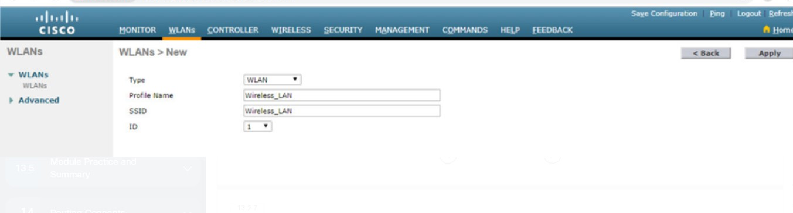

**2. Apply and Enable the WLAN**

After clicking **Apply**, the network administrator must enable the WLAN before it can be accessed by users, as shown in the figure. The Enable checkbox allows the network administrator to configure a variety of features for the WLAN, as well as additional WLANs, before enabling them for wireless client access. From here, the network administrator can configure a variety of settings for the WLAN including security, QoS, policies, and other advanced settings.

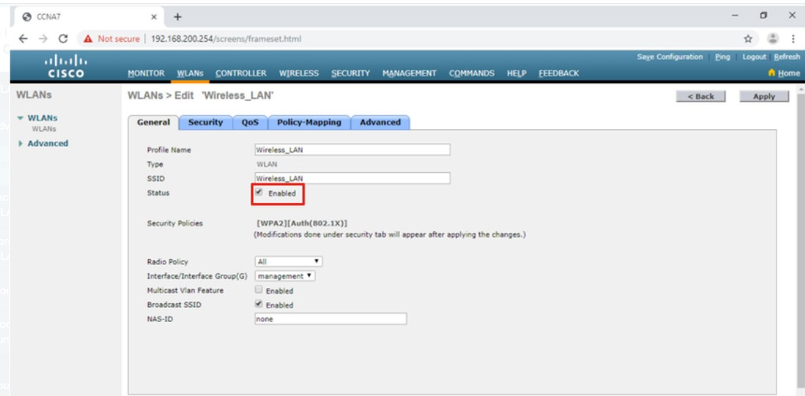

**3. Select the Interface**

When you create a WLAN, you must select the interface that will carry the WLAN traffic. The next figure shows the selection of an interface that has already been created on the WLC. We will learn how to create interfaces later in this module.

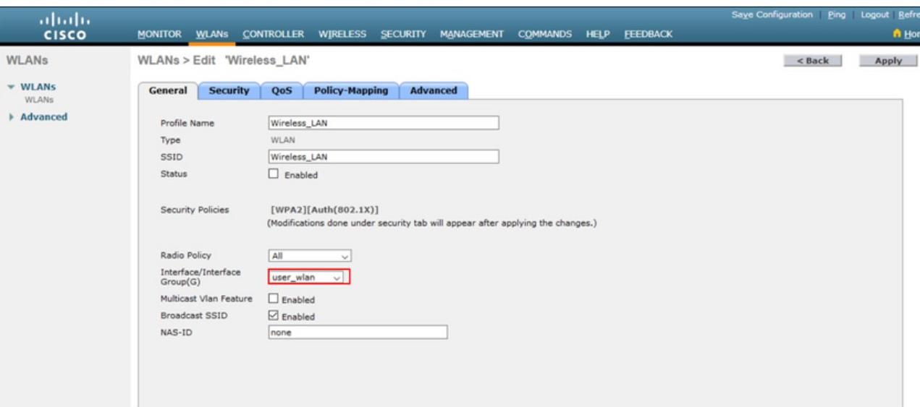

**4. Secure the WLAN**

Click the Security tab to access all the available options for securing the LAN. The network administrator wants to secure Layer 2 with WPA2-PSK. WPA2 and 802.1X are set by default. In the Layer 2 Security drop down box, verify that **WPA+WPA2** is selected (not shown). Click PSK and enter the pre-shared key, as shown in the figure. Then click **Apply**. This will enable the WLAN with WPA2-PSK authentication. Wireless clients that know the pre-shared key can now associate and authenticate with the AP.

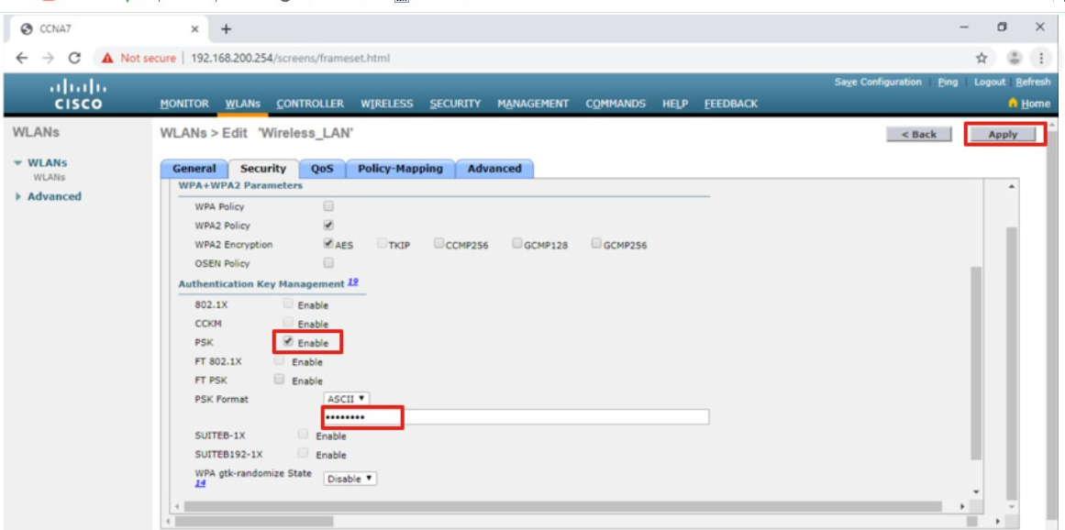

**5. Verify the WLAN is Operational**

Click **WLANs** in the menu on the left to view the newly configured WLAN. In the figure, you can verify that WLAN ID 1 is configured with **Wireless_LAN** as the name and SSID, it is enabled, and is using WPA2 PSK security.

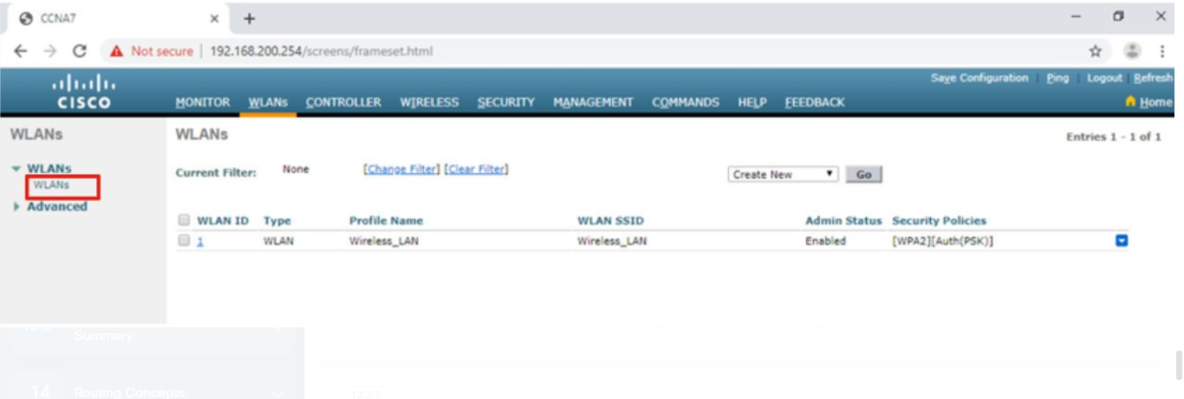

**6. Monitor the WLAN**

Click the **Monitor** tab at the top to access the advanced **Summary** page again. Here you can see that the **Wireless_LAN** now has one client using its services, as shown in the figure.

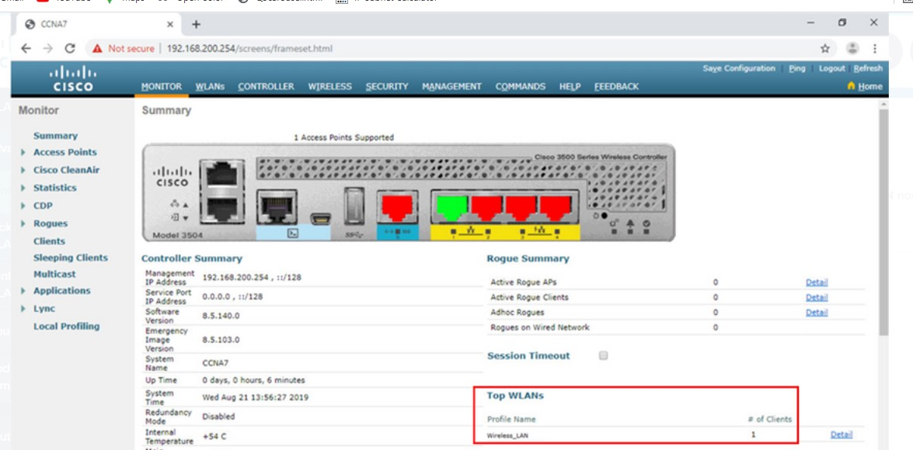

**7. View Wireless Client Details**

Click **Clients** in the left menu to view more information about the clients connected to the WLAN, as shown in the figure. One client is attached to **Wireless_LAN** through AP1 and was given the IP address 192.168.5.2. DHCP services in this topology are provided by the router.

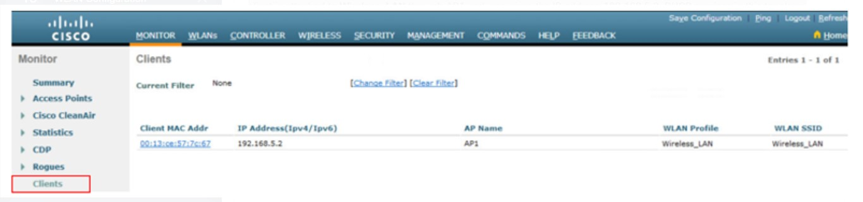

13.2.7

Packet Tracer - Configure a Basic WLAN on the WLC

In this lab, you will explore some of the features of a wireless LAN controller. You will create a new WLAN on the controller and implement security on that LAN. Then you will configure a wireless host to connect to the new WLAN through an AP that is under the control of the WLC. Finally, you will verify connectivity.

**CONFIGURE WPA2 ENTERPRISE WLAN ON THE WLC**

13.3.2

## SNMP and RADIUS

In the figure, PC-A is running Simple Network Management Protocol (SNMP) and Remote Authentication Dial-In User Service (RADIUS) server software. SNMP is used to monitor the network. The network administrator wants the WLC to forward all SNMP log messages, called traps, to the SNMP server.

In addition, for WLAN user authentication, the network administrator wants to use a RADIUS server for authentication, authorization, and accounting (AAA) services. Instead of entering a publicly known pre-shared key to authenticate, as they do with WPA2-PSK, users will enter their own username and password credentials. The credentials will be verified by the RADIUS server. This way, individual user access can be tracked and audited if necessary and user accounts can be added or modified from a central location. The RADIUS server is required for WLANs that are using WPA2 Enterprise authentication.

**Note**: SNMP server and RADIUS server configuration is beyond the scope of this module.

The figure depicts a network topology. PC-A is a RADIUS/SNMP Server connected to R1 on R1s F0/0 interface. PC-B is connected to S1 on S1s F0/6 port. R1 and S1 are connected together on R1s F0/1 interface and on S1s F0/5 interface. S1 is connected to a WLC on its F0/18 port. On S1s F0/1 port its connected to an access point, AP1. A laptop is wirelessly connected to AP1.

### **Topology**

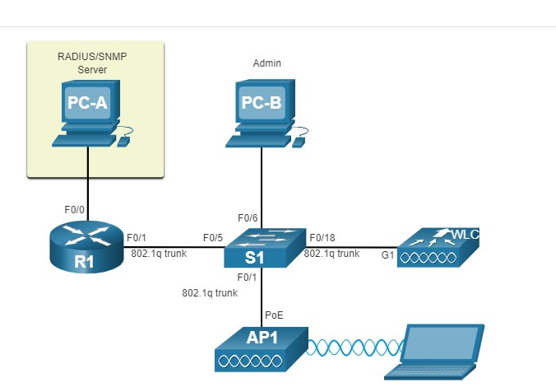

13.3.3

Configure SNMP Server Information

Click the **MANAGEMENT** tab to access a variety of management features. SNMP is listed at the top of the menu on the left. Click **SNMP** to expand the sub-menus, and then click **Trap Receivers**. Click **New...** to configure a new SNMP trap receiver, as shown in the figure.

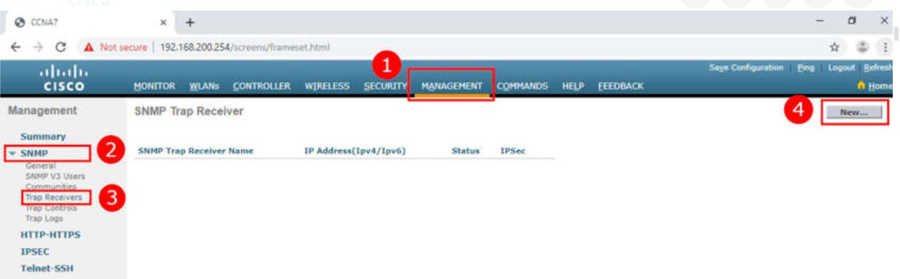

1. Click **MANAGEMENT**
2. Click **SNMP**
3. Click **Trap Receivers**
4. Click **New...**

Enter the SNMP Community name and the IP address (IPv4 or IPv6) for the SNMP server. Click **Apply**. The WLC will now forward SNMP log messages to the SNMP server.

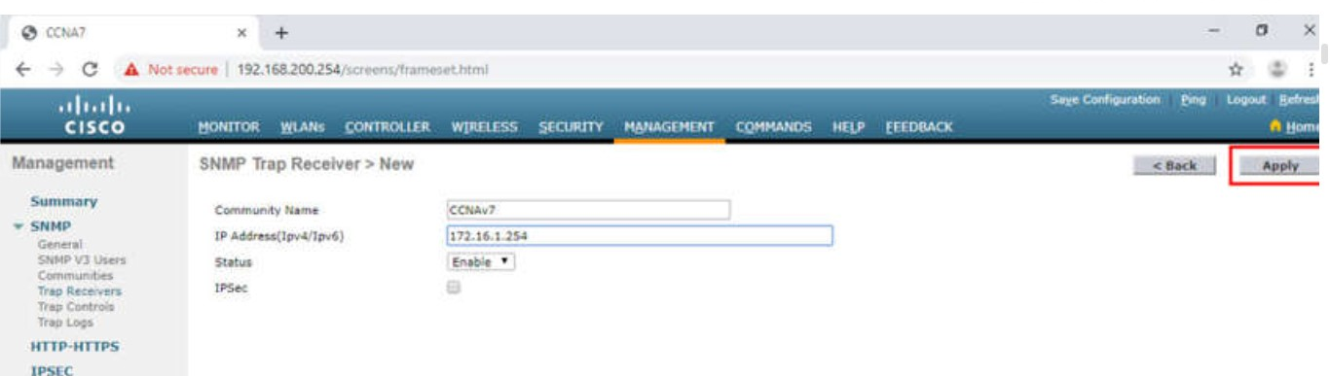

13.3.4

Configure RADIUS Server Information

In our example configuration, the network administrator wants to configure a WLAN using WPA2 Enterprise, as opposed to WPA2 Personal or WPA2 PSK. Authentication will be handled by the RADIUS server running on PC-A.

To configure the WLC with the RADIUS server information, click the **SECURITY** tab > **RADIUS** > **Authentication**. No RADIUS servers are currently configured. Click **New...** to add PC-A as the RADIUS server.

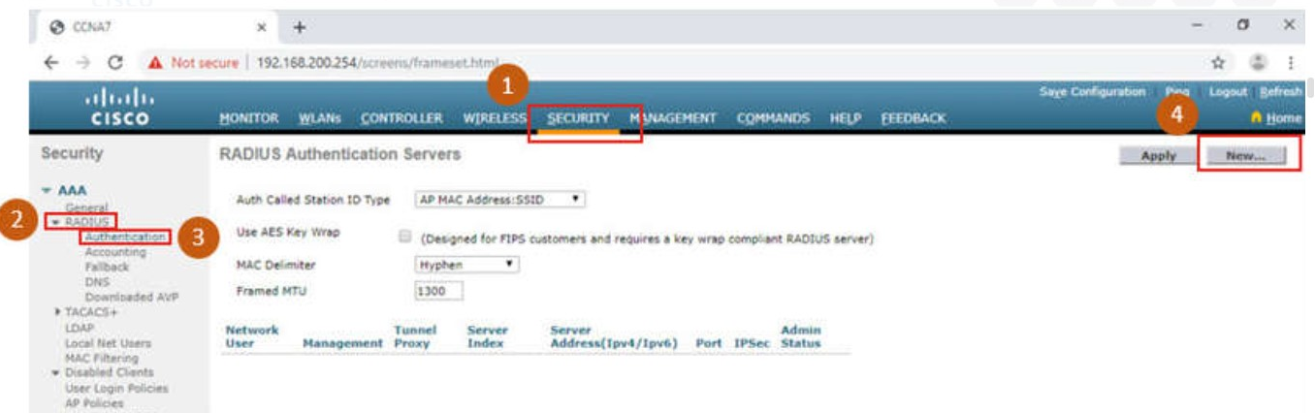

1. Click **SECURITY**
2. Click **RADIUS**
3. Click **Authentication**
4. Click **New...**

Enter the IPv4 address for PC-A and the shared secret. This is the password used between the WLC and the RADIUS server. It is not for users. Click **Apply**, as shown in the figure.

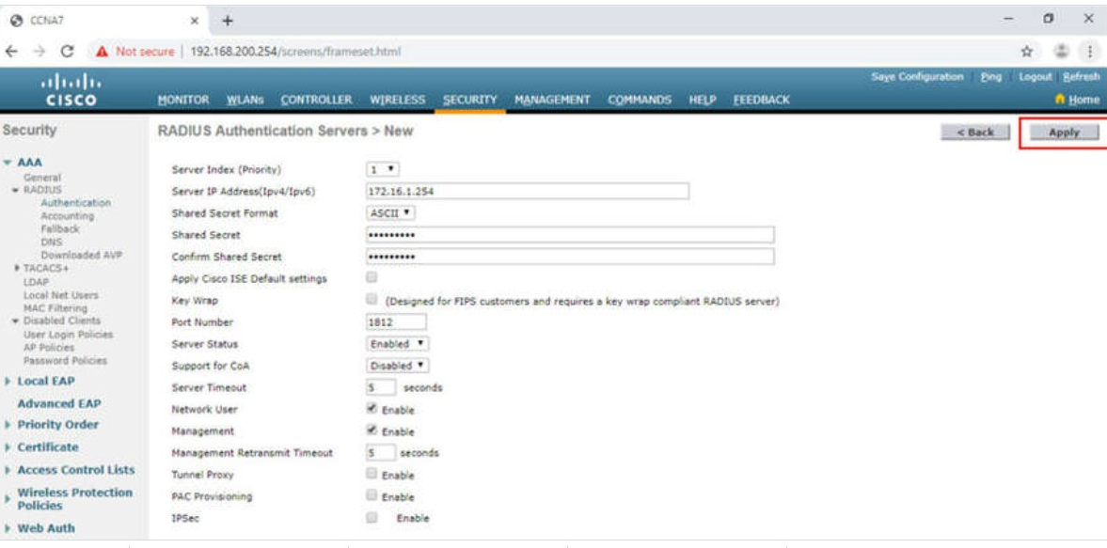

After clicking **Apply**, the list of configured **RADIUS Authentication Servers** refreshes with the new server listed, as shown in the figure.

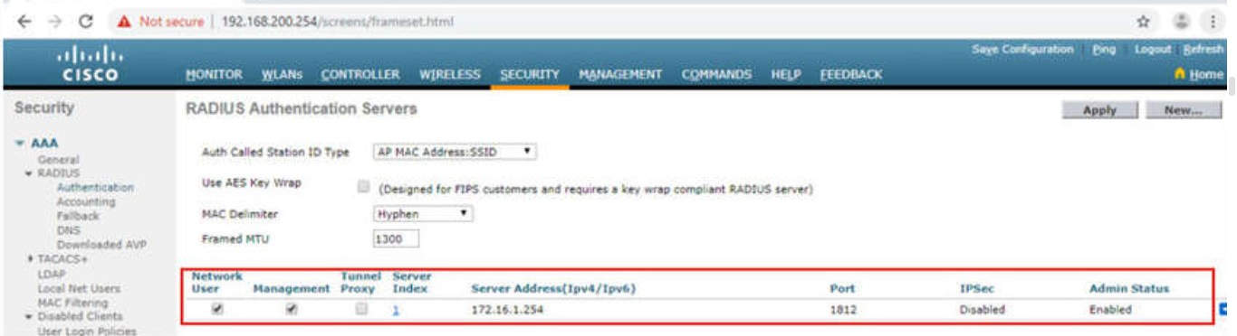

13.3.6

## Topology with VLAN 5 Addressing

Each WLAN configured on the WLC needs its own virtual interface. The WLC has five physical ports for data traffic. Each physical port can be configured to support multiple WLANs, each on its own virtual interface. Physical ports can also be aggregated to create high-bandwidth links.

The network administrator has decided that the new WLAN will use interface VLAN 5 and network 192.168.5.0/24. R1 already has a subinterface configured and active for VLAN 5, as shown in the topology and **show ip interface brief** output.

The figure depicts a network topology. PC-A is a RADIUS/SNMP Server connected to R1 on R1s F0/0 interface. R1 has a sub-interface configured on VLAN 5 with the IP address 192.168.5.1. PC-B is connected to S1 on S1s F0/6 port. R1 and S1 are connected together on R1s F0/1 interface and on S1s F0/5 interface. S1 is connected to a WLC on its F0/18 port. The WLC has the management IP address of 192.168.200.254 and an interface on VLAN 5 with an IP address of 192.168.5.254. On S1s F0/1 port its connected to an access point, AP1. A laptop is wirelessly connected to AP1.

### **Topology**

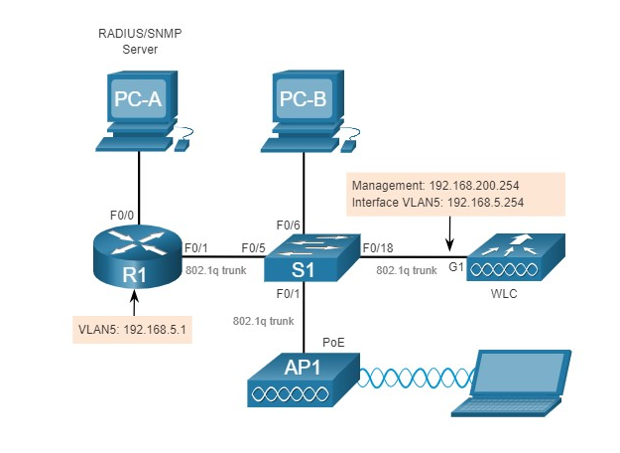

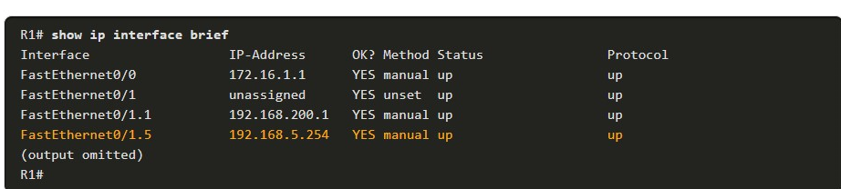

13.3.7

## Configure a New Interface

VLAN interface configuration on the WLC includes the following steps:

1. Create a new interface.
2. Configure the VLAN name and ID.
3. Configure the port and interface address.
4. Configure the DHCP server address.
5. Apply and Confirm.
6. Verify Interfaces.

**1. Create a new interface.**

To add a new interface, click **CONTROLLER > Interfaces > New...**, as shown in the figure.

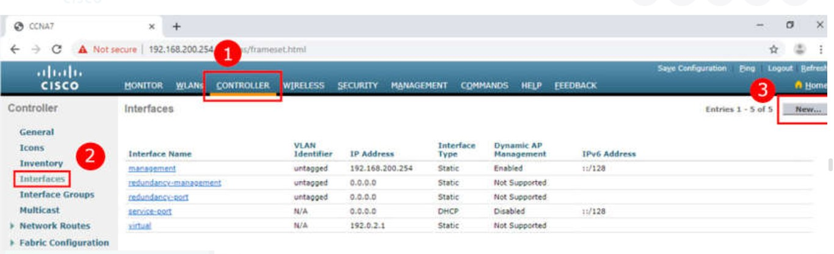

1. Click **CONTROLLER**
2. Click **Interfaces**
3. Click **New...**

**2. Configure the VLAN name and ID.**

In the figure, the network administrator configures the interface name as **vlan5** and the VLAN ID as **5**. Clicking **Apply** will create the new interface.

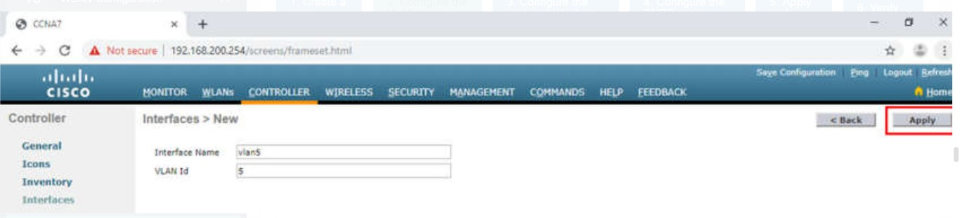

**3. Configure the port and interface address.**

On the **Edit** page for the interface, configure the physical port number. G1 in the topology is Port Number 1 on the WLC. Then configure the VLAN 5 interface addressing. In the figure, VLAN 5 is assigned IPv4 address 192.168.5.254/24. R1 is the default gateway at IPv4 address 192.168.5.1.

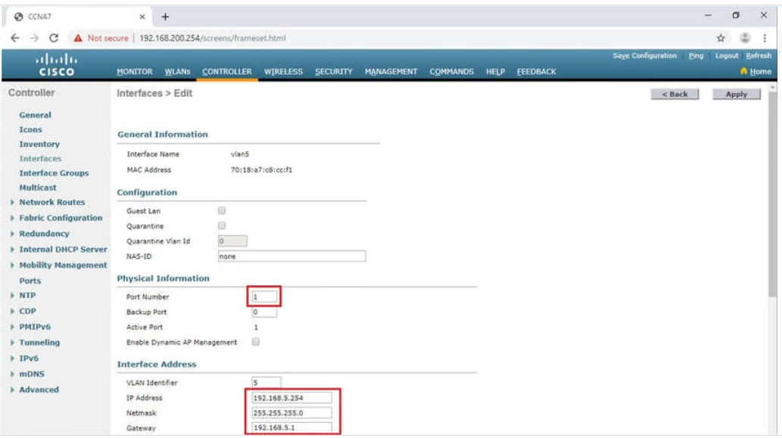

13.3.9

## Configure a DHCP Scope

DHCP scope configuration includes the following steps:

1. Create a new DHCP scope.
2. Name the DHCP scope.
3. Verify the new DHCP scope.
4. Configure and enable the new DHCP scope.
5. Verify the enable DHCP scope

**1. Create a new DHCP scope.**

A DHCP scope is very similar to a DHCP pool on a router. It can include a variety of information including a pool of addresses to assign to DHCP clients, DNS server information, lease times, and more. To configure a new DHCP scope, click **Internal DHCP Server > DHCP Scope > New...**, as shown in the figure.

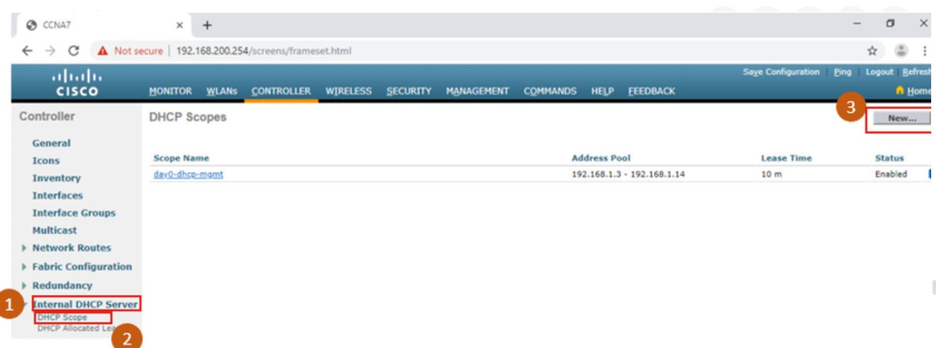

**2. Name the DHCP scope.**

On the next screen, name the scope. Because this scope will apply to the wireless management network, the network administrator uses **Wireless_Management** as the Scope Name and clicks **Apply**.

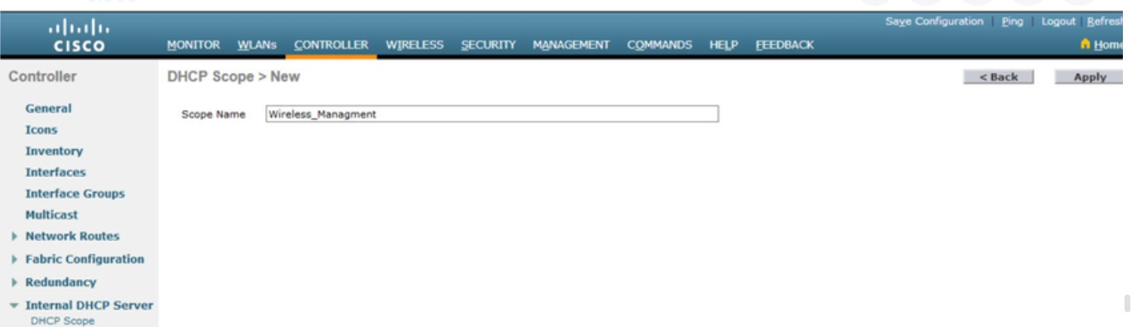

**3. Verify the new DHCP scope.**

You are returned to the **DHCP Scopes** page and can verify the scope is ready to be configured. Click the new Scope Name to configure the DHCP scope.

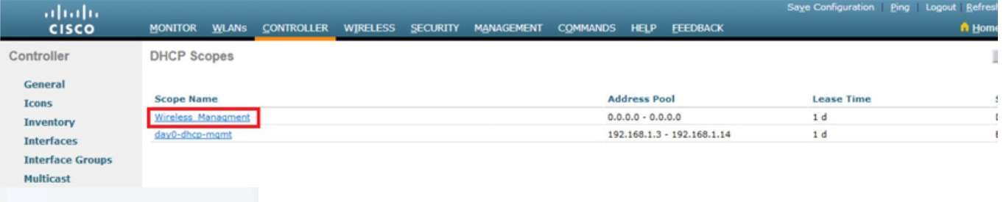

**4. Configure and enable the new DHCP scope.**

On the Edit screen for the **Wireless_Management** scope, configure a pool of addresses for the 192.168.200.0/24 network starting at .240 and ending at .249. The network address and subnet mask are configured. The default router IPv4 address is configured, which is the subinterface for R1 at 192.168.200.1. For this example, the rest of the scope is left unchanged. The network administrator selects **Enabled** from the Status drop down and clicks **Apply**.

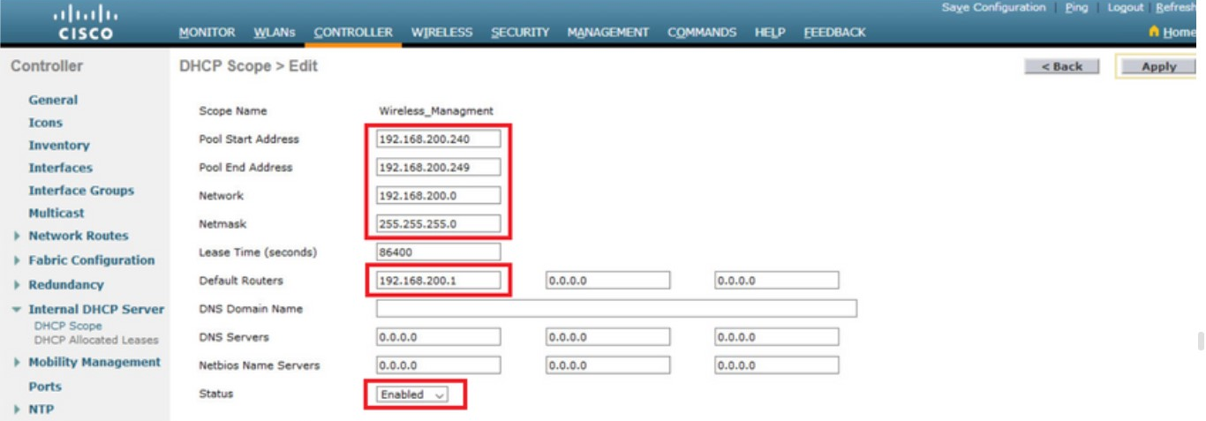

**5. Verify the enable DHCP scope**

The network administrator is returned to the **DHCP Scopes** page and can verify the scope is ready to be allocated to a new WLAN.

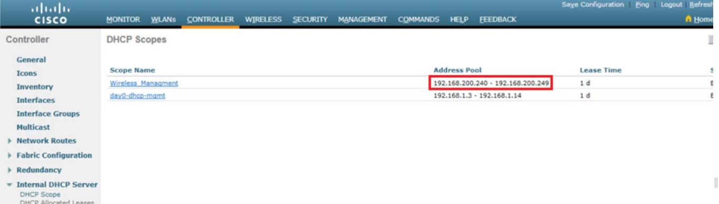

13.3.11

## Configure a WPA2 Enterprise WLAN

By default, all newly created WLANs on the WLC will use WPA2 with Advanced Encryption System (AES). 802.1X is the default key management protocol used to communicate with the RADIUS server. Because the network administrator already configured the WLC with the IPv4 address of the RADIUS server running on PC-A, the only configuration left to do is to create a new WLAN to use interface **vlan5**.

Configuring a new WLAN on the WLC includes the following steps:

1. Create a new WLAN.
2. Configure the WLAN name and SSID.
3. Enable the WLAN for VLAN 5.
4. Verify AES and 802.1X defaults.
5. Configure WLAN security to use the RADIUS server.
6. Verify the new WLAN is available.

**1. Create a new WLAN.**

Click the **WLANs** tab and then **Go** to create a new WLAN, as shown in the figure.

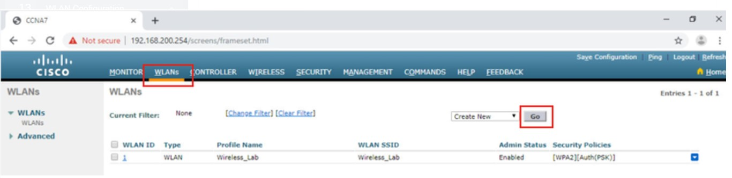

**2. Configure the WLAN name and SSID.**

Fill in the profile name and SSID. In order to be consistent with the VLAN that was previously configured, choose an ID of **5**. However, any available value can be used. Click **Apply** to create the new WLAN, as shown in the figure.

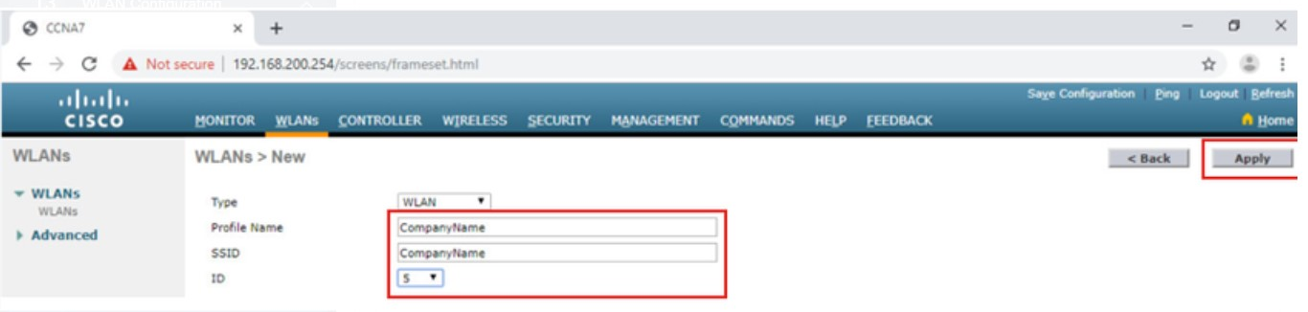

**3. Enable the WLAN for VLAN 5.**

The WLAN is created but it still needs to be enabled and associated with the correct VLAN interface. Change the status to **Enabled** and choose **vlan5** from the Interface/Interface Group(G) dropdown list. Click **Apply** and click **OK** to accept the popup message, as shown in the figure.

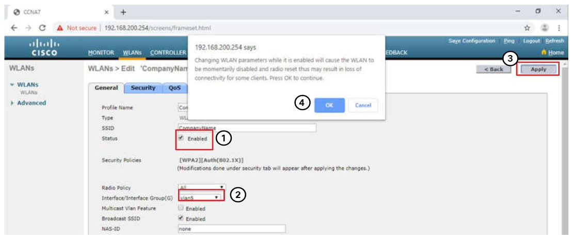

**4. Verify AES and 802.1X defaults.**

Click the **Security** tab to view the default security configuration for the new WLAN. The WLAN will use WPA2 security with AES encryption. Authentication traffic is handled by 802.1X between the WLC and the RADIUS server.

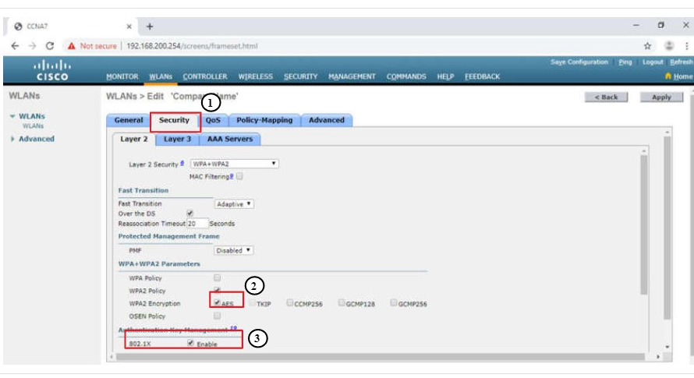

**5. Configure the RADIUS server.**

We now need to select the RADIUS server that will be used to authenticate users for this WLAN. Click the **AAA Servers** tab. In the dropdown box select the RADIUS server that was configured on the WLC previously. Apply your changes.

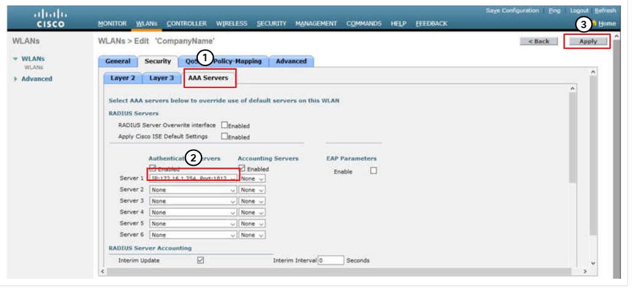

**6. Verify that the new WLAN is available.**

To verify the new WLAN is listed and enabled, click **Back** or the **WLANs** submenu on the left. Both the **Wireless_LAN** WLAN and the **CompanyName** WLAN are listed. In the figure, notice that both are enabled. **Wireless_LAN** is using WPA2 with PSK authentication. **CompanyName** is using WPA2 security with 802.1X authentication.

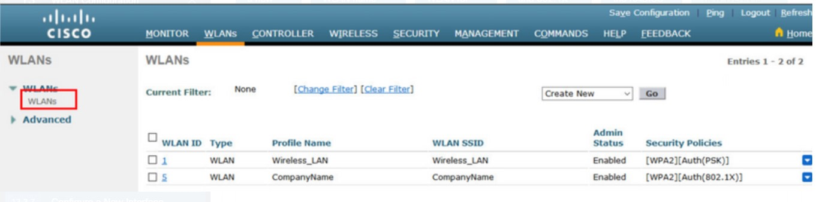

13.3.12

Packet Tracer - Configure a WPA2 Enterprise WLAN on the WLC (pending 13.3.12)

In this activity, you will configure a new WLAN on a wireless LAN controller (WLC), including the VLAN interface that it will use. You will configure the WLAN to use a RADIUS server and WPA2-Enterprise to authenticate users. You will also configure the WLC to use an SNMP server.

**TROUBLESHOOT WLAN ISSUES**

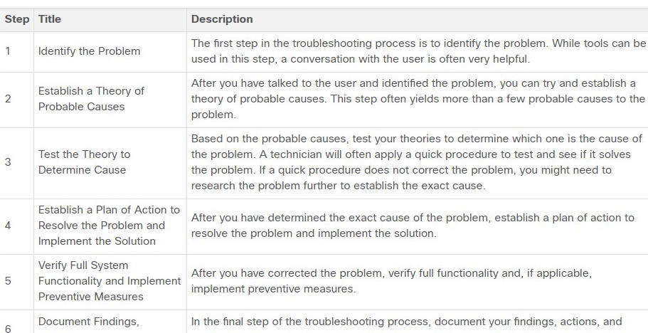

To assess the problem, determine how many devices on the network are experiencing the problem. If there is a problem with one device on the network, start the troubleshooting process at that device. If there is a problem with all devices on the network, start the troubleshooting process at the device where all other devices are connected. You should develop a logical and consistent method for diagnosing network problems by eliminating one problem at a time.

13.4.2

Wireless Client Not Connecting

When troubleshooting a WLAN, a process of elimination is recommended.

In the figure, a wireless client is not connecting to the WLAN.

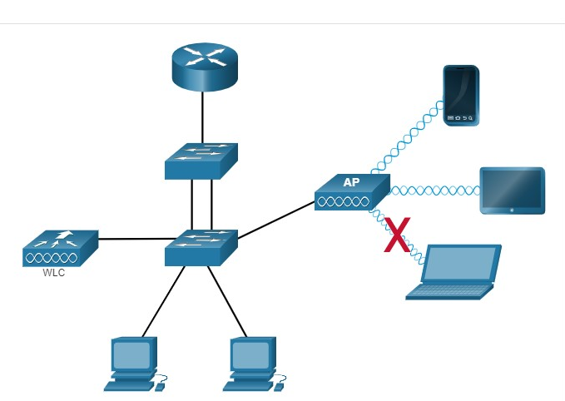

If there is no connectivity, check the following:

* Confirm the network configuration on the PC using the **ipconfig** command. Verify that the PC has received an IP address via DHCP or is configured with a static IP address.
* Confirm that the device can connect to the wired network. Connect the device to the wired LAN and ping a known IP address.
* If necessary, reload drivers as appropriate for the client. It may be necessary to try a different wireless NIC.
* If the wireless NIC of the client is working, check the security mode and encryption settings on the client. If the security settings do not match, the client cannot gain access to the WLAN.

If the PC is operational but the wireless connection is performing poorly, check the following:

* How far is the PC from an AP? Is the PC out of the planned coverage area (BSA)?
* Check the channel settings on the wireless client. The client software should detect the appropriate channel as long as the SSID is correct.
* Check for the presence of other devices in the area that may be interfering with the 2.4 GHz band. Examples of other devices are cordless phones, baby monitors, microwave ovens, wireless security systems, and potentially rogue APs. Data from these devices can cause interference in the WLAN and intermittent connection problems between a wireless client and AP.

Next, ensure that all the devices are actually in place. Consider a possible physical security issue. Is there power to all devices and are they powered on?

Finally, inspect links between cabled devices looking for bad connectors or damaged or missing cables. If the physical plant is in place, verify the wired LAN by pinging devices, including the AP. If connectivity still fails at this point, perhaps something is wrong with the AP or its configuration.

When the user PC is eliminated as the source of the problem, and the physical status of devices is confirmed, begin investigating the performance of the AP. Check the power status of the AP.

13.4.3

## Troubleshooting When the Network Is Slow

To optimize and increase the bandwidth of 802.11 dual-band routers and APs, either:

* **Upgrade your wireless clients** - Older 802.11b, 802.11g, and even 802.11n devices can slow the entire WLAN. For the best performance, all wireless devices should support the same highest acceptable standard. Although 802.11ax was released in 2019, 802.11ac is most likely that highest standard that enterprises can currently enforce.
* **Split the traffic** - The easiest way to improve wireless performance is to split the wireless traffic between the 802.11n 2.4 GHz band and the 5 GHz band. Therefore, 802.11n (or better) can use the two bands as two separate wireless networks to help manage the traffic. For example, use the 2.4 GHz network for basic internet tasks, such as web browsing, email, and downloads, and use the 5 GHz band for streaming multimedia, as shown in the figure.

The figure depicts a home network splitting the traffic between 2.4GHz and 5GHz. The WLC is connected to a television, cell phone and tablet using 5GHz. It is also connected to two laptops using 2.4 GHz.

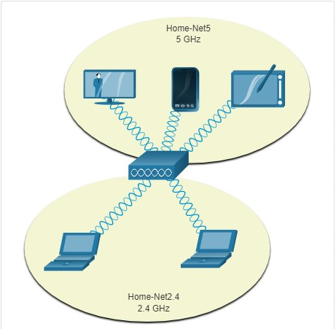

There are several reasons for using a split-the-traffic approach:

* The 2.4 GHz band may be suitable for basic Internet traffic that is not time-sensitive.
* The bandwidth may still be shared with other nearby WLANs.
* The 5 GHz band is much less crowded than the 2.4 GHz band; ideal for streaming multimedia.
* The 5 GHz band has more channels; therefore, the channel chosen is likely interference-free.

By default, dual-band routers and APs use the same network name on both the 2.4 GHz band and the 5 GHz band. The simplest way to segment traffic is to rename one of the wireless networks. With a separate, descriptive name, it is easier to connect to the right network.

To improve the range of a wireless network, ensure the wireless router or AP location is free of obstructions, such as furniture, fixtures, and tall appliances. These block the signal, which shortens the range of the WLAN. If this still does not solve the problem, then a Wi-Fi Range Extender or deploying the Powerline wireless technology may be used.

13.4.4

Updating Firmware

Most wireless routers and APs offer upgradable firmware. Firmware releases may contain fixes for common problems reported by customers as well as security vulnerabilities. You should periodically check the router or AP for updated firmware. In the figure, the network administrator is verifying that the firmware is up to date on a Cisco Meraki AP.

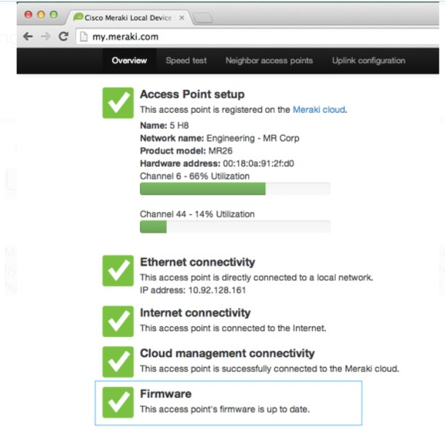

On a WLC, there will most likely be the ability to upgrade the firmware on all APs that the WLC controls. In the next figure, the network administrator is downloading the firmware image that will be used to upgrade all the APs.

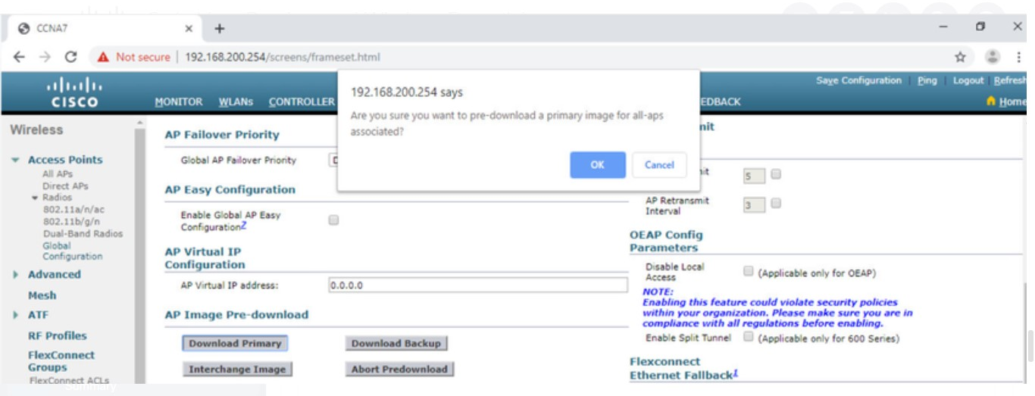

On a Cisco 3504 Wireless Controller, Click the **WIRELESS** tab > **Access Points** from the left menu > **Global Configuration** submenu. Then scroll to the bottom of the page for the AP Image Pre-download section.

Users will be disconnected from the WLAN and the internet until the upgrade finishes. The wireless router may need to reboot several times before normal network operations are restored

13.4.5

Packet Tracer - Troubleshoot WLAN Issues

Now that you have learned how to configure wireless in home and enterprise networks, you need to learn how to troubleshoot in both wireless environments. Your goal is to enable connectivity between hosts on the networks to the Web Server by both IP address and URL. Connectivity between the home and enterprise networks is not required.

13.5.1

Packet Tracer - WLAN Configuration

In this activity, you will configure both a wireless home router and a WLC-based network. You will implement both WPA2-PSK and WPA2-Enterprise security.

13.5.2

### **Packet Tracer - Wireless Technology Exploration**

XYZ Corporation is expanding their network capabilities to allow enhanced connectivity at their local offices, as well as connectivity for those wishing to work remotely. In this Packet Tracer Physical Mode (PTPM) activity, you have been asked to assist with this plan by reviewing the current network capabilities and adding wireless functionality as required.

**Note**: Please be patient. It may take several minutes for this PTPM activity to load.

13.5.3

What did I learn in this module?

Remote workers, small branch offices, and home networks often use a wireless router, which typically include a switch for wired clients, a port for an internet connection (sometimes labeled “WAN”), and wireless components for wireless client access. Most wireless routers are preconfigured to be connected to the network and provide services. The wireless router uses DHCP to automatically provide addressing information to connected devices. Your first priority should be to change the username and password of your wireless router. Use your router’s interface to complete basic network and wireless setup. If you want to extend the range beyond approximately 45 meters indoors and 90 meters outdoors, you can add wireless access points. The router will use a process called Network Address Translation (NAT) to convert private IPv4 addresses to Internet-routable IPv4 addresses. By configuring QoS, you can guarantee that certain traffic types, such as voice and video, are prioritized over traffic that is not as time-sensitive, such as email and web browsing.

Lightweight APs (LAPs) use the Lightweight Access Point Protocol (LWAPP) to communicate with a WLAN controller (WLC). Configuring a wireless LAN controller (WLC) is similar to configuring a wireless router except that a WLC controls APs and provides more services and management capabilities. Use the WLC interface to view an overall picture of the AP’s system information and performance, to access advanced settings and to configure a WLAN.

SNMP is used monitor the network. The WLC is set to forward all SNMP log messages, called traps, to the SNMP server. For WLAN user authentication, a RADIUS server is used for authentication, accounting, and auditing (AAA) services. Individual user access can be tracked and audited. Use the WLC interface to configure SNMP server and RADIUS server information, VLAN interfaces, DHCP scope, and a WPA2 Enterprise WLAN.

There are six steps to the troubleshooting process. When troubleshooting a WLAN, a process of elimination is recommended. Common problems are: no connectivity and poorly performing wireless connection when the PC is operational. To optimize and increase the bandwidth of 802.11 dual-band routers and APs, either: upgrade your wireless clients or split the traffic. Most wireless routers and APs offer upgradable firmware. Firmware releases may contain fixes for common problems reported by customers as well as security vulnerabilities. You should periodically check the router or AP for updated firmware.

1. A user is configuring a wireless access point and wants to prevent any neighbors from discovering the network. What action does the user need to take?

Topic 13.1.0 - Disabling SSID broadcast prevents the access point from announcing the name of the network. Enabling WPA encryption, configuring DMZ settings, and configuring a DNS server  will accomplish different tasks, but the name of the network will still be announced.



Configure a DNS server.



Disable SSID broadcast.



Configure DMZ settings.



Enable WPA encryption.

1. When a wireless network in a small office is being set up, which type of IP addressing is typically used on the networked devices?

Topic 13.1.0 - In setting up the wireless network in a small office, it is a best practice to use private IP addressing because of the flexibility and easy management it offers.



network



private



public



wireless

1. A user has just purchased a generic home router and would like to secure it. What should be done to help secure the wireless home router?

Topic 13.1.0 - The home router allows a designated administrator to manage the network. Anyone who knows the account username and password can log into the router itself, which grants complete access to the features of the device  and information about any devices that are connected. Most router manufacturers configure their new routers with the same default username and password and thus changing the default administrator password is a step towards securing the home router.



Change the default administrator password.



Change the default SSID.



Allow only IPv6 traffic to enter the router.



Set a private IPv4 network for the internal network.

1. Which protocol could be used by a company to monitor devices such as a wireless LAN controller (WLC)?

Topic 13.3.0 - The Simple Network Management Protocol (SNMP) is an application layer protocol used to monitor and manage the network. Network devices must be configured with a community name and IP address of the SNMP server.



NTP



SSH



SNMP



PAT

1. When configuring a Cisco 3500 series wireless LAN controller (WLC) for a WPA2 Enterprise WLAN, what has to be created on the WLC before creating the new WLAN?

Topic 13.3.0 - On a Cisco 3500 series wireless controller, a new interface for each new wireless network controlled by the WLC must be created. The interface and VLAN are created before configuring the wireless network.



a security module



a VLAN for the wireless network



a security policy



a new SSID

1. What is a DHCP scope as it relates to a WLAN configured on the WLC controller?

Topic 13.3.0 - When configuring a WLC controller as a DHCP server, use the **DHCP Scope** menu option to configure IP address-related settings such as the range of IP addresses to assign to WLAN devices, a DNS server address, and lease time.



a pool of IP addresses for WLAN clients



a corporate plan for allocation of IP addresses for wireless clients



the distance allotted for wireless clients that can receive IP addressing information



security rules associated with DHCP for WLANs

1. Why would a technician configure a passphrase for a WLAN on a wireless router?

Topic 13.1.0 - When a WLAN on a wireless router is being configured, a passphrase is used in the wireless security settings for a specific security mode. Clients must be configured for the same security mode and the same passphrase in order to access the WLAN.



to protect the SSID from being changed



to configure wireless client authentication



to protect someone from changing the configuration



to protect someone from cabling directly to the router and accessing the router

1. A customer installs a wireless access point at home in the closet next to the kitchen.  The customer mentions that the wireless communication performance seems degraded when the cordless phone or the microwave oven is in use.  What is the possible reason for this degradation?

Topic 13.4.0 - Because wireless networks use air as a medium, interference from other sources commonly cause degradation issues. Sources can include cordless phones, fluorescent lighting, microwave ovens, and other wireless devices that use the same frequencies.



The surge of electricity when a microwave oven is in use disrupts the operation of the access point.



The access point is close to walls.



The cordless phone joins the WLAN and shares the available bandwidth.



The wireless signal is in the same radio frequency range as the household devices are in.



The access point is on the same electrical circuit as the phone base unit and microwave oven are.

1. What functionality is required on routers to provide remote workers with VoIP and videoconferencing capabilities?

Topic 13.1.0 - Quality of service (QoS) needs to be enabled on routers to provide support for VoIP and videoconferencing. QoS refers to the capability of a network to provide better service to selected network traffic, as required by voice and video applications.



IPsec



VPN



PPPoE



QoS

1. A wireless router is displaying the IP address of 192.168.0.1. What could this mean?

Topic 13.1.0 - Wireless routers usually come with factory default settings. The IP address is often set to 192.168.0.1. The default username and password are often **admin.** The IP address, username, and password should all be modified to help secure the router.



Dynamic IP address allocation has been configured on the router and is functioning correctly.



The wireless router has been configured to use the frequencies on channel 1.



The NAT function is not working on the wireless router.



The wireless router still has the factory default IP address.

1. A laptop cannot connect to a wireless access point. Which two troubleshooting steps should be taken first? (Choose two.)

Topic 13.4.0 - A wireless laptop normally does not have an antenna attached unless a repair has recently been implemented. If the wireless NIC is enabled, the correct media, radio, will be used. When the NIC detects an access point, the correct frequency is automatically used.



Ensure that the NIC is configured for the proper frequency.



Ensure that the wireless NIC is enabled.



Ensure that the laptop antenna is attached.



Ensure that the wireless SSID is chosen.



Ensure that the correct network media is selected.

1. In setting up a small office network, the network administrator decides to assign private IP addresses dynamically to workstations and mobile devices. Which feature must be enabled on the company router in order for office devices to access the internet?

Topic 13.1.0 - Network Address Translation (NAT) is the process used to convert private addresses to internet-routable addresses that allow office devices to access the internet.



MAC filtering



NAT



UPnP



QoS

1. What is a difference between autonomous APs that operate in a home environment and controller-based APs that operate in a corporate environment?

Topic 13.2.0 - Autonomous APs are standalone devices that are configured via Cisco CLI or a GUI. Controller-based APs are server-dependent devices that require no initial configuration to operate, because they are automatically configured and managed by a WLAN controller. Most autonomous and controller-based APs support PoE.



Controller-based APs can be automatically configured and managed by a WLAN controller.



Autonomous APs incorporate the functions of a router, switch, and AP into one device.​



Autonomous APs do not support PoE.



Controller-based APs are known as lightweight APs and require an initial configuration to operate.

1. Which WLC tab would a network administrator typically use to see a summary view of the most heavily used WLANs including the number of clients using a particular WLAN?

Topic 13.2.0 - Use the **Monitor** tab and then the **Summary** option to see information about the WLC, including the IP address and system uptime as well as information associated with the top WLANs configured and active within the organization.



**Monitor**



**WLANs**



**Commands**



**Controller**

1. Users on an IEEE 802.11n network are complaining of slow speeds. The network administrator checks the AP and verifies it is operating properly. What can be done to improve the wireless performance in the network?

Topic 13.4.0 - The easiest way to improve wireless performance is to split the 802.11n wireless traffic between the 2.4 GHz band and the 5 GHz band. IEEE 802.11n networks can use the two bands as two separate wireless networks to help manage the traffic.



Switch to an 802.11g AP.



Set the AP to mixed mode.



Split the wireless traffic between the 802.11n 2.4 GHz band and the 5 GHz band.



Change the authentication method on the AP.